1. we will create Apache ActiveMQ Artemis Broker an MQ Broker which will be used as JMS Provider or Server.  
   Command: C:\V1000-Practice\Messaging\Java Message Service - JMS Fundamentals\apache-artemis-2.31.0\bin>**./artemis** **create** **C:\V1000-Practice\Messaging\Java Message Service - JMS Fundamentals\artifacts  
     
   ./artemis: The exe file:  
   create: The operation we want to perform like here we want to create a new broker.**

**C:\V1000-Practice\Messaging\Java Message Service - JMS Fundamentals\artifacts: The location where we want to set up new broker from there we will start the newly created broker. There you can see a bunch of files.**

1. 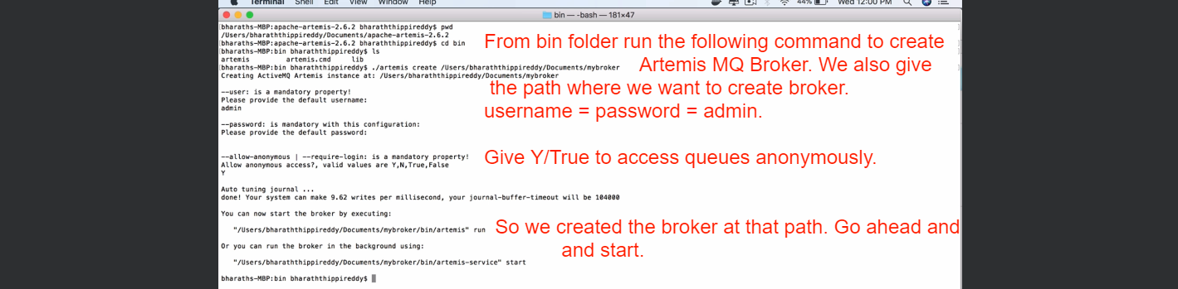
2. 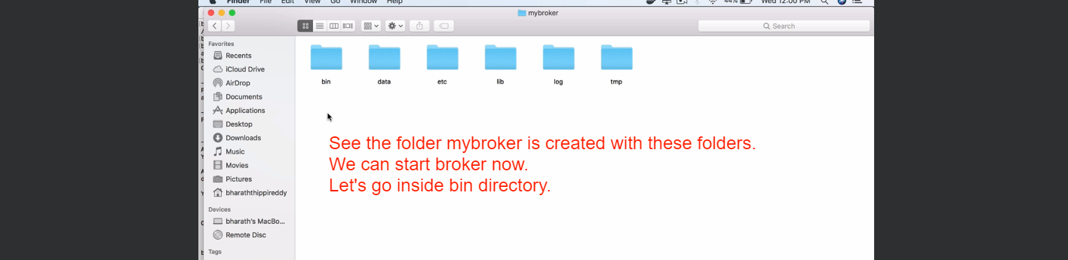
3. 
4. 